Bootstrap has quite a large CSS library built by Bootstraps developers using thousands of use cases. How it achieves this is through CSS classes and their variations through in fixes and modifiers. It is important that you as a developer, understand in fixes and modifiers and you will explore each of these terms. You will use class in fixes for responsive breakpoints in the Bootstrap grid system, let's go ahead and cover how in fixes are used. You already know that breakpoints are the triggers in bootstrap for how your layout changes across device or viewpoint sizes. Here are the responsive breakpoints available in bootstrap and how we use them.
Know that each has a specific name.
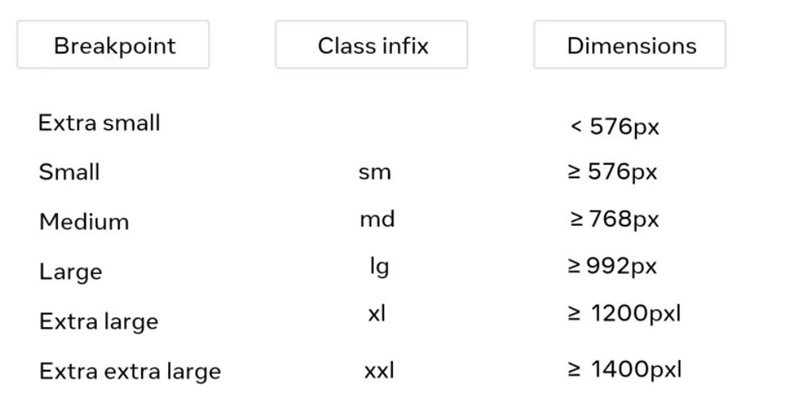
Did you notice that there is no class in fix or dimension for extra small on the list? This is because extra small is the default breakpoint in Bootstrap CSS rules.
As bootstrap is mobile first. We use the abbreviations for these breakpoints as in fixes in the CSS rules for the grid system. This basically means you have to insert the abbreviation into the CSS class name. I will show you how to use this shortly. Bootstrap components provide a pre built set of reusable UI styles and elements for your web applications. Let's now learn how to use modifiers through an example that uses an alert element. I can have an html file where I set an alert primary CSS class that is applied to the element.
Alert primary displays the alert using Bootstraps primary color which is blue. The dash primary part of the class is the modifier.

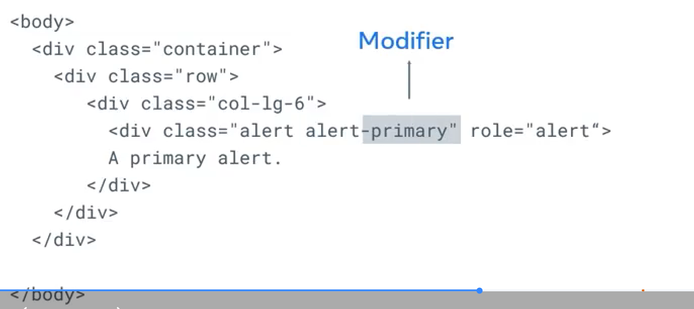
If you want to change this to red for example, for an error message you will use the danger modifier. Here is a list of modifiers available in Bootstrap:

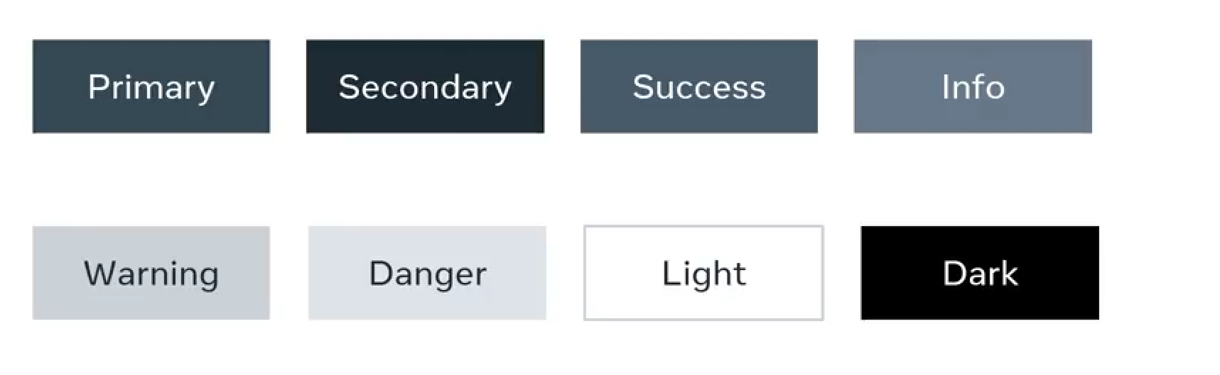
Alerts are often used to show information that needs immediate attention from users such as warnings, errors or confirmation messages. Bootstrap provides an easy way to create predefined alert messages and it also has different types of alerts.
The difference between the alerts is just the color used to display the predefined alert message. For example, the primary alert displays the alert using bootstraps primary color which is blue. On the other hand, the danger alert displays the alert in red.

